
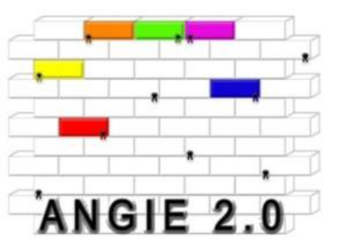

Let’s go to Europe !

May this booklet be so useful to help the student during the three steps of his European experience: the time of preparation, the period abroad and the analysis after the stage. We hope that this notebook will help the young worker to grow his own personal development and his professional project.

Here you are, ready to go abroad! You are leaving to discover, learn, share and receive…

You are leaving because you have a stage to manage.

You are leaving to let some pieces of you here and there.

You are going to realize your own identity, to know the reality in other countries, and grow by yourself as a European citizen.

Nota : This booklet is based on the French complete booklet ‘’En Route vers l’Europe”. You can, of course, translate it in your own language, and use it as a tool to help the students more easily to fill their blog and assess them.
Frederik Chapron – CFA Jules Rieffel – Saint-Herblain, France – frederik.chapron@educagri.fr

- BEFORE YOUR DEPARTURE
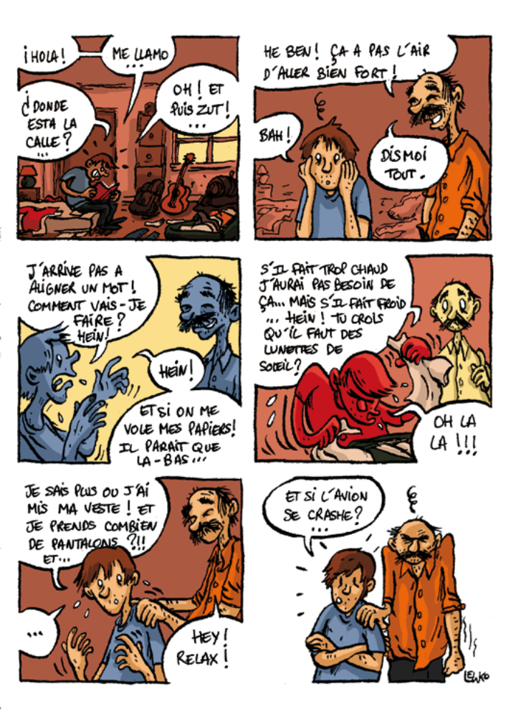
Damn it ! I can’t do it !
Hey ! What’s the matter ? You don’t look confident !
Tell me…
I just can’t speak properly ! How will I manage it ?
And if I lose my ID card ?
Hey !
If the weather is hot, I won’t need this, but if it’s cold… Do you think I need my sunglasses ?
Where did I put my coat ? and how many trousers do I need ? and…
And if the plane crashes ?
- WHY DO YOU LEAVE ?
A- What are your motivations?
Look after several pictures of the country you are going to. Pick up two of them, which represent your personal motivations, and answer the question « why do I want to go to this country for my stage?”.

B- What are you looking for?
What are your wishes, your expectations? Can you give 3 of them ?
What are your fears? Can you give 3 of them ?
For example : the fear of plane, to be worried about the language, about the food, about being far away from your family and friends, to get bored during your free time…

- CULTURE, REPRESENTATIONS and STEREOTYPES

A- How do you imagine the country you choose to go ?
- Can you give : 3 places (monuments, natural spaces, in town…) ; 3 celebrities ; 3 historical or cultural events ; 3 dishes or drinks ?

- Can you give : 3 attracting things and 3 mysterious things from this country ?

REPRÉSENTATIONS and STÉRÉOTYPES
- What kind of stereotypes do you have about the country and the people you are going to meet ?
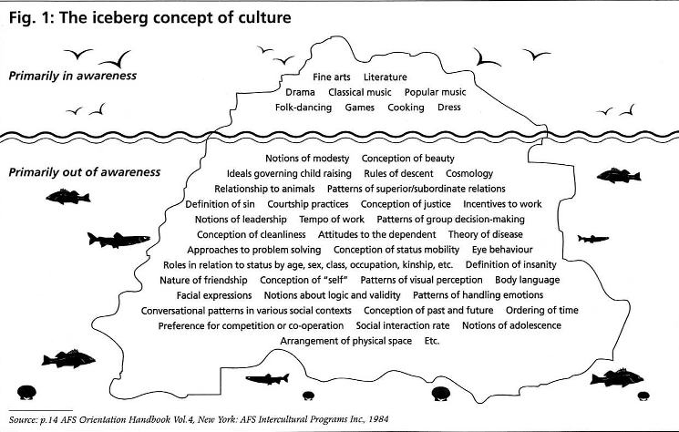

3. GET SOME INFORMATIONS ! JUST BE CURIOUS !
- Politic : what kind of government ? date of entrance in Europe ?
- History : do you know the relationship between this country and yours ?
- Geography : surface of the country ? how many habitants ? what kind of demography?
- Economy : what are the most important activities ? what is the main agriculture production ?

4. PREPARE YOURSELF TO COMMUNICATE
- SURVIVAL KIT 1 : VOCABULARY OF GENERAL CONVERSATION

- SURVIVAL KIT 2 : VOCABULARY OF PROFESSIONAL WORDS

5. PREPARE YOUR STAGE

What do you need in your bag ?

  - Your identity card and your transport tickets
  - Your convention
  - This booklet « Let’s go to Europe ! »
  - Some useful addresses
  - Your survival kits (vocabulary)
  - The touristic guide
  - Personal picture of your family and environment; to show to the people you will meet there
  - A traditional recipe that you can prepare, to share a meal
  - Some music, to make them discover your artists
  - Some traditional food to share
  - Pens and paper
  - A little present for your manager
  - …

- DURING YOUR STAY
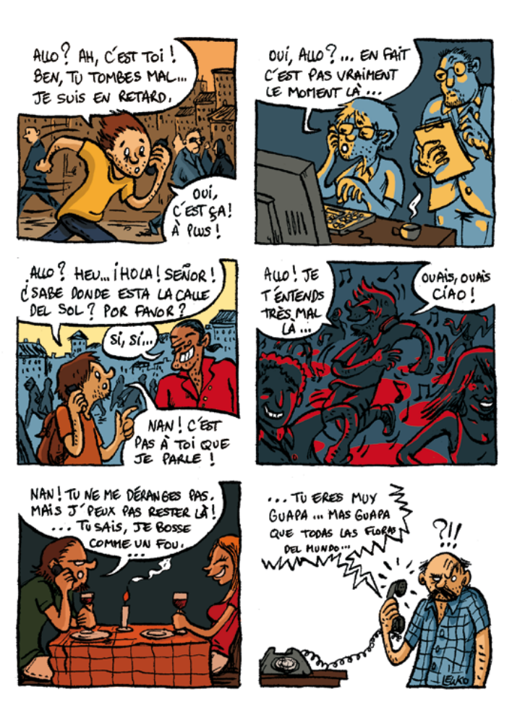
Allo ? Hi dad ! Listen, it’s not the right time, I am late…
Ok ; later, bye !
Allo ? Not the right moment, again…
No dad, I’m not talking to you…
Can’t hear you, sorry !
Ok, bye !
No, you are not disturbing me… But I can’t talk any longer, I am so busy…

1. MY DAILY EXPERIENCE
A- What I am living :
A local market / a show / a museum / a festival / a sport / a traditional recipe / a visit in a company / rent a bike / …

B- How do I observe :
Ethnographical approach of the people and cultural practices :
It concerns the daily life, the daily things we use, how do we act (eat, wear cloths, play…) and also ideas, social organizations… This approach takes care about several dimensions : historical, psychological, economic, social, cultural….

The tools for a good ethnographical approach
- A pad or notebook
- An observation
Here are several examples of direct observations :
- You can decide to observe during 15 minutes in the company, or one hour in a public place or during a traditional day…
- Observe a traditional event of the local life (traditional party, market, café…), the way the people is acting…
- Observe what the students do, what are their habits...
- During a meal, describe the menu, the order of the dishes,…

Write ideas and take pictures, to help you for your evaluation…

C- How do I ask ?Make some interviews…
Example : the meals : what do you eat ? who cooks ? can you describe me a daily meal ? what so you eat on Sundays ? and for special events : Christmas, weddings, Easter, New Year’s Eve…?

2. I RETURN WHAT I AM LIVING
A – Create a blog
How do you start :
  - make yourself your interface
  - Write as soon as you can about your daily experience
  - Careful : when you are writing on your blog, think about all the persons who will read your texts. What do they need to know ?
  - If you want to put a picture of someone, ask before to make sure this person is approving you !

B- Make a photo report

- ANTICIPATE THE NEXT STEP : “I’M BACK HOME…”

A- The stage

Very good / Good / Average / bad / very bad

B- My experience
What is your best memory ?

Because of this project, did you change your mind about :
- Your judgment ? Yes / No
- Your behavior ? Yes / No
- Your attitude at work ? Yes / No
- Your interest for study ? Yes / No
- Your representation about the country visited ? Yes / No
- Your capacities to adapt yourself to different situations ?Yes / No
- Your capacities to communicate ? Yes / No

What did you like… and dislike about :
- Daily life
- Sports and leisures
- Speaking in an other language
- Work
- Professional visits
- Cultural visits
- Work in team
- Other :

What difficulties did you have during your stay ?
- Communicate with the group
- Communicate with the habitants
- Daily life (timetable, food…)
- Foreign language
- Being far away from family and friends
- To be alone sometimes, or to often
- Work in team
- Other :

- YOU ARE BACK AT HOME…
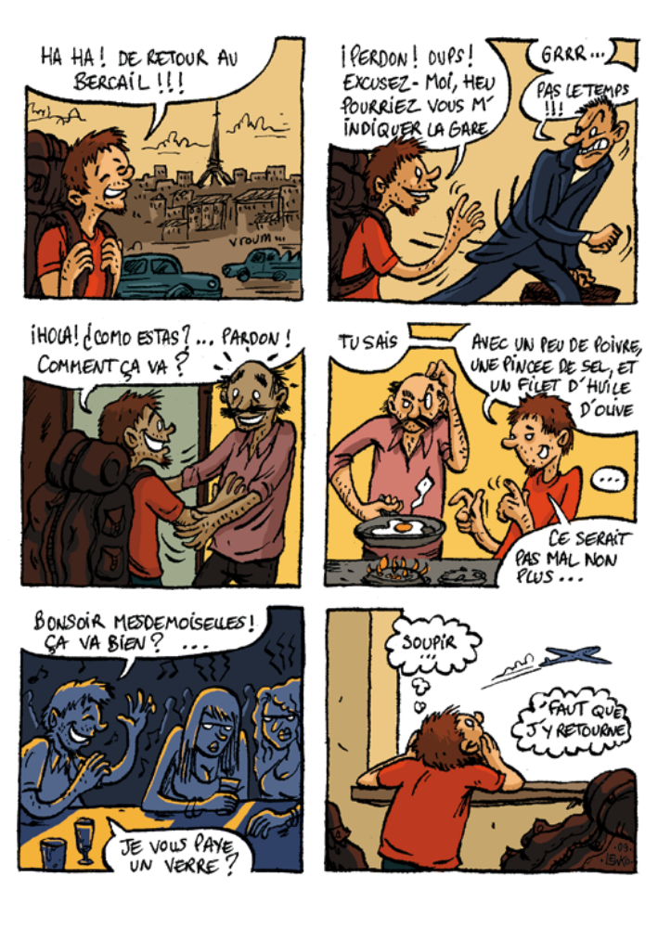
Aaaah ! Home sweet home…
Perdon ! Er… Sorry, where is the station ?
No time !!
Holà : Como estas ? … Sorry ! How are you dad ?
You know…
With some pepper, olive oil and salt…
It could be nice too...
Hi girls ! everything’s fine ?
You want a drink ?
go back there…
Sigh…

Here you are, back at home, with some memories in your bag and full of pictures ! You just lived a rich professional and personal experience. You know how much you changed ! Take your time to breathe and find your marks.
Keep a print of this unique experience and make an assessment of what you lived. This third part will help you to realize what you have done, to go over your difficulties and project yourself in the future.

- THE DEBRIEFING

- Do you tell the same things to your family and to your friends ?
- Are they ready to hear everything ?
- Do you remember what was the first thing you told them ?
- What were their questions ?

- On the personal plan
You can take a picture of what seems to be emotional for you : your family, your empty room, your bag opened, your clothes, your papers… You will choose later a picture in all the set, and give him a title.

B- On the professional plan
Keep all the useful documents for your assessment.

- FEEDBACK ABOUT THE EXPERIENCE

A – The strong and the weak points of your experience :
- This experience is unforgettable because…
- Some aspects could be better, like…
- My own private list of small failures : create a list of your own small failures will help you to realize all the efforts you made…

B – Feedback on the wishes, the expectations and fears you had about this experience :
Wishes and expectations you had before you left : what do you think about them today ?
Fears you had before you left : what do you think about them today ?

- WHAT DOES THIS EXPERIENCE BRING TO YOU :

1 – Know-how and social skills :
Description of one situation : on a professional way / on a personal way / on the cultural differencies… : how did you react ? were you able to… ?

2 – My portfolio of competences :

- Competencies in language

- Social competencies
Capacity to live and work with other persons : communication, team spirit…

- Organisational competencies
Capacity to coordoante and built some projects

- Technical competencies

- Competences with computer
Software, internet, keyboard…

- Artistic competencies

- Other competencies
Center of interest, sports, responsabilities

