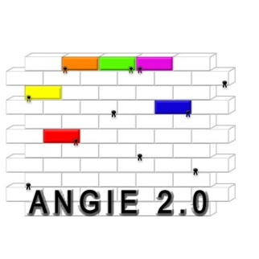
ANGIE 2.0
A New Generation In Education 2.0

ANGIE 2.0. The reason: The world becomes smaller, the mutual contacts intensified. Students must get acquainted with other cultures and international components to prepare them for an international labour market. Individuals will have to adapt and learn. To reach the maximum effect of learning, a student needs to make a connection between (work) experiences and theoretical knowledge gained in the school. To be able to establish this connection, a student needs to develop his competences not only within the school, but also in an authentic learning environment, the workplace.
Studying and working abroad gives authentic learning an extra dimension for VET students: to establish formal learning in another country. To realize this formal learning, ECVET units need to be developed and the learning outcomes validated. In an (international) setting, formal and informal learning takes place.
To transfer informal learning into formal learning is rewarding but very challenging, unexplored process.
The project aims are to develop and validate a methodology to recognize, assess and validate formal and informal learning in the authentic international workplace to contribute to the formal degree handed out by the students own education institution in their home country.
The methodology will be developed and tested in a pilot-project in tailor-made ECVET-units.
This project will improve the general understanding of citizens′ learning outcomes and their transparency, transnational mobility and portability across and will also improve the mobility and portability of qualifications. Furthermore, it will contribute to the development and expansion of European cooperation in education and training.
The ANGIE 2.0 dissemination seminar will provide methods and tools to implement the outcomes.
Consortium: All the partners are members of EUROPEA International, a European network for land-based education with over 1200 agricultural institutes involved. Their role in ANGIE 2.0 project will be developing the innovative tools and products listed in section 3.4, take part in the pilots concerning international competences, language and management, transfer the developed products within their own country and organize dissemination networks in their own countries.

Outcomes:
Website and intranet communication platform
A manual with information about the methodology of recognizing, assessing and validating informal learning
Manual with information about ECVET-units and about informal learning
Identification and validation informal learning
Discription of ECVET-unit Language, International Competences and International Management
Dissemination seminar
Envisaged impact:
Students are able to study abroad and build up their diploma with ECVET units.
Teachers and coaches get handles to work with ECVET units and know how to implement these units with informal learning in the curriculum of the students.

In an (international) setting, formal and informal formal learning takes place. To transfer informal learning into formal learning is rewarding but very challenging, unexplored process. It requires teachers/assessors who can recognize informal learning and are capable of transferring this learning towards formal learning. The development of teachers and assessing on-the-job learning played an important part in the project ALIVE DK/LLP-LdV-ToI/2008/809. This new project ANGIE 2.0, addresses the requirement of flexible, high quality VET systems which respond to the needs of today and tomorrow and are connected to the working world to remain up-to-date and competitive. Agricultural VET has to become more capable of attracting learners from other European countries, providing them with education and training as well as recognition of prior learning (ECVET).

The following needs arise:
• Sustainability, excellence and internationality of agricultural VET needs to be sustained: ECVET units will encourage mobility between European institutes.
• The VET institutions are not using all the possibilities when it comes to learning and assessing: There is no methodology to recognize formal and informal learning yet

All these indicators are found in the Bruges Communiqué and in the Copenhagen Declaration.

The ANGIE 2.0 project aims to develop and validate a methodology to recognize, assess and validate formal and informal learning in the authentic international workplace to contribute to the formal degree handed out by the students own education institution in their home country. This methodology will be described in a manual and entails various aspects regarding the recognition of the various ways of learning for assessing and validating these learning outcomes. The methodology will be developed and tested in a pilot-project in tailor-made ECVET-units. The purpose of the ECVET Recommendation is to create a European Credit System for Vocational Education and Training (‘ECVET’) intended to facilitate the transfer, recognition and accumulation of assessed learning outcomes of individuals who are aiming to achieve a qualification. These learning outcomes could be gained by formal and informal learning in the international authentic workplace.

This will improve the general understanding of citizens′ learning outcomes and their transparency, transnational mobility and portability across and will also improve the mobility and portability of qualifications at national level between various sectors and within the labour market. Furthermore, it will contribute to the development and expansion of European cooperation in education and training. The objectives, linked to the European priorities that this project strives to achieve can be described as follows:

1. To Identify and validate formal, (non formal) and informal learning to strengthen the comparability and transparency of validation approaches and methods in ECVET units.
2. To embed EQF in the ECVET units and quality assurance reference framework for vocational education and training/ Dissemination products
3. To develop and pilots ECVET-units concerning international competences, language and management
4. To develop a manual that entails a broad outline of the methodology, a description of requirements and guidelines for implementing the methodology for recognizing, assessing and validating formal and informal learning in ECVET units
5. To have a dissemination seminar of the outcomes of the project

The outcomes of this project can be used and transferred to any sector within the vocational education system. The transfer of the innovation in this project will be implemented in the agricultural sector, due to the fact that all partners are related to this sector. The agricultural sector is known for its good relationship between learning in the school and learning in the authentic workplace. Students from all levels get practical experience, hands-on activities and experience the working world of the agricultural sector during their education. All partners have developed a certain expertise in authentic and competence based learning. Some are further developed than others, viewpoints and experiences may differ: the best way to transfer each other’s knowledge and good practice is by learning from each other. Main goal is to experience in a very practical, hands-on didactical approach, within five working meetings related to the work packages, how the implementation of the innovation can be realized in all the partner countries. A pilot project with the developed ECVET units regarding international competences, language skills and management will take place in the authentic agricultural setting. Students from different countries will be part of this pilot. Assessors from various countries will monitor the students learning process and use the developed methodology in order to try to recognize, assess and validate the learning outcomes gained by formal and informal learning. An evaluation where partners, including Agri-Business will be present, will take place in order to further develop and adjust the methodology. The end result of this pilot leads to a manual that entails a broad outline of the methodology, a description of requirements and guidelines for implementing the methodology for recognizing, assessing and validating formal and informal learning in ECVET units.

As all partners are members of EUROPEA International, the outcomes of the pilot and the results of the evaluations will be transferred within this association. All partners in this project will use the manual to transfer the methodology in their own county.

Conclusion: Two types of innovations will be transferred:
The developed and piloted ECVET units in an authentic agricultural context
A developed and validated methodology for recognizing, assessing and validating formal and informal learning

This project will use some of the products that are developed during the ALIE / ALIVE projects about formal authentic learning, competence based learning, assessing and professionalization of teachers / workplace learning guides. These products are developed internationally and accordingly to the aim that all the various partners from different countries with their different development stages should be able to transfer them to their own situation.

In order to develop a methodology for assessing formal and informal learning, some of the products form ALIE / ALIVE will be used. The main products that will be used during this project are:
The STAR-Method has been used as a tool for criteria-oriented interviews and was used as tool to assess ALIE teachers in the ALIVE project. This method and tool will be used for developing the methodology because this method allows an assessor to question the student regarding situations that may have led to formal and or informal learning.
The concept of a portfolio as developed in ALIVE in order to proof that a student/teacher has gained certain competences of formal learning will be used as a model in this project. The outline of the product will be modified in order to contribute to the development of the methodology for assessing formal and informal learning.
During the ALIE and ALIVE projects, examples of good practice of formal learning have been collected. These examples will be used to recognize formal learning and possible in informal learning. An outline for an assessment of informal learning will be the main goal.
Another product is a methodology for assessing teachers as competent authentic teachers (CAT). The partners have used a specific guideline, taken various steps in order to develop the methodology. This guideline will be used as steppingstones in order to develop the methodology for assessing formal and informal learning.

The initial developers of these products are current partners in ANGIE 2.0. Their knowledge, experience and attitude developed during ALIE and ALIVE are valuable “products” for the new ANGIE project.

A growing number of teachers are using specific pedagogical materials as: authentic assessments, case-based exams, exhibitions, portfolios, and problem-based project. Teachers use these tools as a support in assessing the student’s formal learning in an authentic learning context. These tools provide support for teachers and are therefore valuable not only for recognizing formal learning, but most likely for recognizing informal learning. The tools will need further adjustment to assess and validate the various forms of non formal and informal learning in the authentic, international context within an ECVET unit.

Competence based learning in the authentic, real life, context means a new connection between the learning world and the working world, but also acknowledging the various ways of learning. Validation of informal learning is very much related to this. The purpose is to define the competences held by an individual, independent of the context where the learning took place. It is a contribution to a student’s development and formal degree when having the full range of skills and competences valued.

Teachers have to become more sophisticated in their understanding of the effects of context and recognizing all types of learning. Instead of implementing set routines, teachers need to become ever more skillful in their ability to evaluate situations and develop and use methodologies of assessing and validating various forms of learning that can be effective under different circumstances.

On the international scientific level research in the development of competence based curricula and the specific tools needed for assessing competences and validating learning outcomes has been done by various social scientists. Amongst others, the following existing pedagogical materials will be used in the project as fundament for the further development. “Identifying of the main principles underlying assessment on competence and taking stock of practices in the European Union”, Colardyn, Danielle/ The effect of practical experience on perceptions of assessment, authenticity, study approach, and learning outcomes”, Gulikers, Judith T.M; Kester, Liesbeth; Kirschner Paul A; Bastiaens, Theo J., (2007)/ “Evaluation assessment quality in competence-based education”, Baartman, Prins, Kirschner, van der Vleuten./ “Defining authentic assessments”, Gulikers, Bastiaens, Kirschner e.a. (2007)/ “Designing constructivist learning environments”, Reigeluth, C.M. (1999)

The basic approach on which products will be based is the social constructivist theory. It is important to note that constructivism is not a particularly pedagogy. Constructivism is a theory describing how learning happens and suggests that learners construct knowledge out of their experiences. Constructivism is often associated with pedagogic approaches that promote active learning, or learning by doing. Learning by doing as well as learning in real life situations will be the didactical approach used in this project.

All learning has value but can only lead to a degree when it is made visible, recognized and validated. But how to assess non-formal and informal learning in the European Vocational Education system? Under which condition(s) can the learning that has not been recognized be assessed, validated and lead to a certificate or degree? It requires teachers/workplace guides/assessors who can actually recognize informal learning and are capable of transferring this learning towards formal learning. Based on these didactical principles, tools will be used and further developed that are linked to this approach: ECVET format, interview techniques, STAR-method, portfolio development, evaluation by assessing the authentic task in real professional situation, and recognition and validation of informal learning are important methods. The vocational education institutions are not using all the possibilities when it comes to learning and assessing learning in authentic situations. Policy-makers are trying to develop strategies to use all the skills, knowledge and competences – wherever they are developed – individuals may gain. There is no methodology to recognize informal and non formal learning in the international authentic workplace: this methodology needs to be developed, based on tools recognizing formal learning. The process that leads to the methodology, will start with determining the correct definition of formal, non formal and informal learning. The next step will be describing various indicators for the various types of learning to recognize them. Not only do standards, ECVET units and assessments tools need to be specified, but also, the requirement for the assessment tools such as reliability, validity and quality procedures needs to be defined. This in such a way that the target user (teacher/assessor) is capable of using the tools assessing a student in an authentic work / learning environment.
A student uses the workplace and the school to consciously develop competences that lead to a degree or diploma, also known as formal learning. In an (international) workplace, during day to day activities, at the sportsclub and so on, not only students but everybody can learn without a conscious purpose, known as informal learning. Informal learning is learning that has no explicit purpose, what casually and coincidentally, unplanned, unconscious constitutes during day to day working activities. It concerns those spontaneous, casual situations that lead to improving the formal repertoire of a degree. Informal learning can only happen if a person is open towards new experiences and learning. It is not structured in terms of learning objectives or apprenticeship and it is not specifically focused towards obtaining a certificate. However, this does not mean that informal learning is invaluable. If a person gains new knowledge and insight during these activities, he could become aware of the development and decide to set individual learning goals and therefore transferring the informal learning to non-formal learning. If this non-formal learning is institutionalized, the learning can be called formal learning which leads to a degree. This is a very challenging, unexplored process. All learning has value but can only lead to a degree when it is made visible, recognized and validated.

Raising awareness of daily on-the-job learning enhances non-formal life-long learning. It should be possible to validate this learning. The specific aims for work package 2 are therefore defined as follows:
• Share experience on informal and non-formal learning and ECVET
• Define the terms non-formal and informal learning
• Improve knowledge on assessing non-formal and informal learning
• Develop a methodology to recognize formal and informal learning in the international authentic workplace, using the tools form ALIE and ALIVE, input from experts, experience from the partners and the various literature that is available

Standards, modules and assessments tools need to be specified. The requirement for the assessment tools such as reliability, validity and quality procedures need to be defined. Assessment uses various tools, but the quality of the process has to be ensured. A methodology include a step by step description of the various processes that will have to take place in order to recognize and assess the learning (examinations, duration, frequency, grading scale, evidence and proofs to be collected) and the procedures for validation of the learning. These standards are important elements as they provide information on the methodology. To reasonably consider that the learning, skills and competences assessed are transfer able over time and locations, it is necessary to ensure that the assessment method is both reliable and valid. Therefore the methodology will be tested within the ECVET units. The results of the pilot will be used to develop a manual. A workable manual which entails step by step procedures, examples, concepts and formats to recognize, assess and validate non-formal and informal learning and how to transfer them to formal learning system will be developed. A summary will be available for students.

- Write a plan of action on how to develop the manual
- Brainstorming about the content.
- Using the methodology and the results of the pilot, the experience from the partners, various literature and input from experts in order to define the requirements for the assessment tools:
o Develop a step by step description of the various processes that will have to take place in order to recognize and assess the learning (examinations, duration, frequency, grading scale, evidence and proofs to be collected)
o Develop the procedures for validation of the learning.
- Write the manual with examples, concepts and formats

The aim of this work packages is to develop three ECVET units. One for language, one for international competences and one for management. A pilot in which students are able to acquire competences by learning in another country (school and the workplace) will be drafted. Allocating certain ECVET points to this pilot will be one of the goals. Learning about the credit system itself, adjusting the partners own tools and methods to develop the ECVET unit, defining what is needed to form a reliable partnership between institutions etc. will be the result of this work package. It will give the project an authentic context to test the developed methodology in order to recognize, assess and validate non-formal and informal learning.

Working on similar discriptions for three pilots for ECVET units. One for language, one for international competences and one for management. For each of the three ECVET units, the following steps will be taken. This will be done in various groups using each other’s expertise and experience with the help of experts, literature and already available materials.

1. The first thing to consider is what the main goal of the ECVET units is: What do students need to achieve?
2. Develop clear and specific objectives: deciding what the learning outcomes of the ECVET unit should entail, considering the VET level the unit will be developed for.
3. Objectives should also be directly measurable. The broad objectives will be described like goals and include the overall goal of the unit, while the specific objectives would be more detailed.
4. Correlate the ECVET unit with standards from each in the pilot participating country and recording links to those standards
5. Determine what will be learned within the classroom and what the student will have to learn at the authentic work place
6. Write an assessment / evaluation plan: the developed methodology in WP 3 will be used and specified to determine whether or not the objectives were reached.
7. Determine didactics.
8. Write a lesson plan which includes an Anticipatory Set, materials used etc
9. Develop a teacher manual: step-by-step procedures that will be performed to reach the objectives
10. Determine how many credits the ECVET unit will be worth

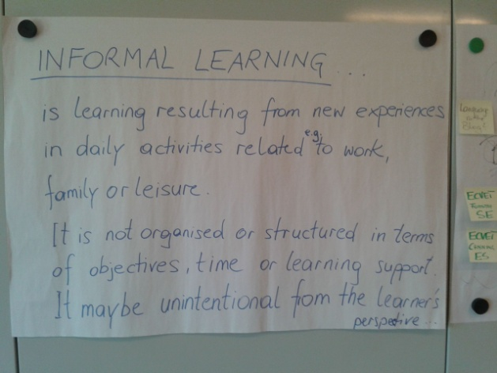

Summary
Consortium: All the partners are members of EUROPEA International, a European network for land-based education with over 1200 agricultural institutes involved. Their role in ANGIE 2.0 project will be developing the innovative tools and products listed in section 3.4, take part in the pilots concerning international competences, language and management, transfer the developed products within their own country and organize dissemination networks in their own countries.

D.3.2.
3. To develop and pilots ECVET-units concerning international competences, language and management

D.3.6. + D4
All the partners are members of EUROPEA International, a European network for land-based education with over 1200 agricultural institutes involved. Their role in ANGIE project will be developing the innovative tools and products listed in section 3.4, take part in the pilots concerning international competences, language and management, transfer the developed products within their own country and organize dissemination networks in their own countries.

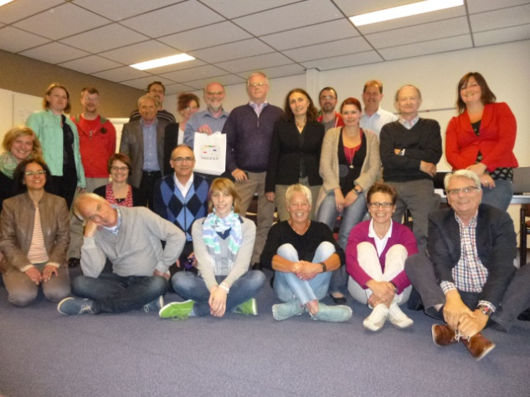

WP4
Working on similar discriptions for three pilots for ECVET units. One for language, one for international competences and one for management. For each of the three ECVET units, the following steps will be taken. This will be done in various groups using each other’s expertise and experience with the help of experts, literature and already available materials.

WP6
Workshops about the outcomes of the ECVET –pilots

D4.4.
Evaluation of the pilots and discussions with the locally established platforms and presentations in seminars gives the target groups a lot of possibilities to developed procedures and outcomes.

D.4.5.
On European level we indicate the outcomes of the pilots from every partner country.

